MySQL Assignment -1

Creating 1st table of SALESPEOPLE :
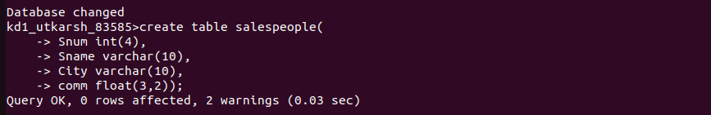

Inserting 1st table of SALESPEOPLE :

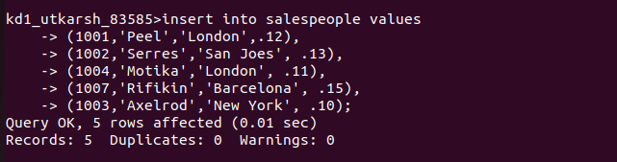

Final Table :
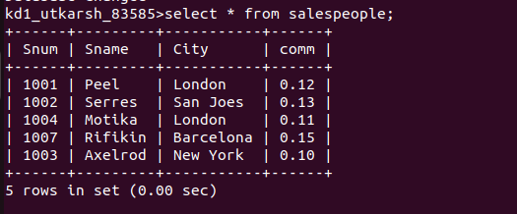

Creating 2nd table of CUSTOMERS :
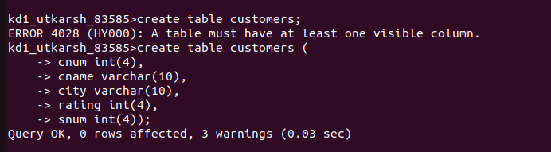
Inserting 2nd table of CUSTOMERS :

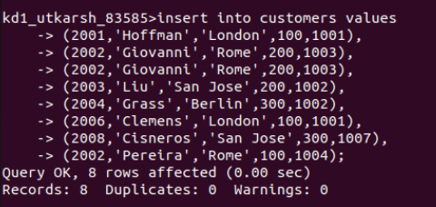
Final Table:


Creating 3rd table for ORDERS :
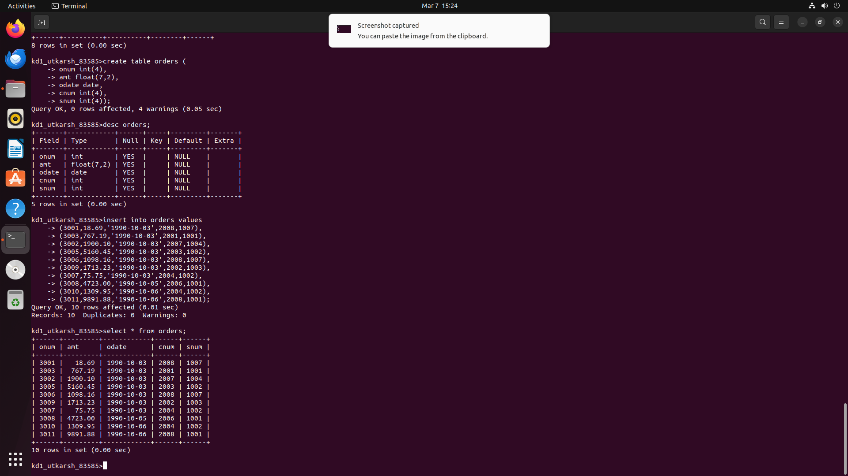
Inserting 3rd table for ORDERS :

Final Table :

